**Ideation Phase**

**Define the Problem Statements**

|  |  |
| --- | --- |
| **DATE** | 19 September 2022 |
| **TEAM ID** | PNT2022TMID52021 |
| **PROJECT TITLE** | Personal assistance for seniors who are self-reliant |
| **MAXIMUM MARK** | 2 Marks |

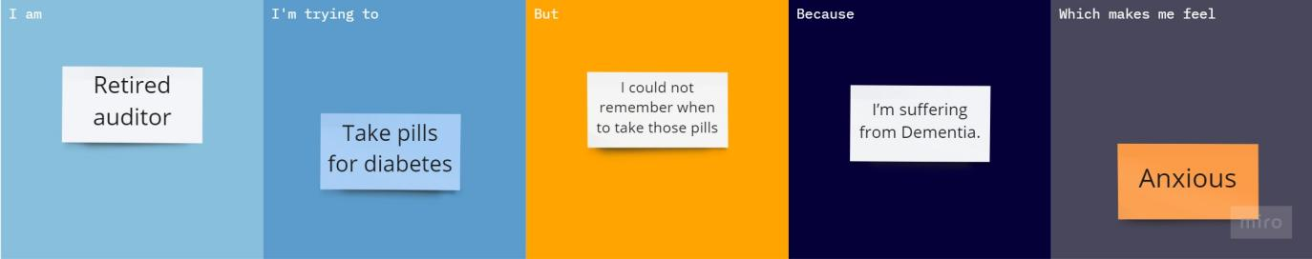

|  |  |
| --- | --- |
| **Problem Statement (PS):** | Senior citizens,who forget to take medicines dues to suffering from “Dementia.” |
| **I am (USER)** | A retired auditor, who spends most of the time at home. |
| **I’m trying to** | who takes pills for diabetes.  (Diabetes is a persistent sickness that happens both while the pancreas does now no longer produce sufficient insulin or while the frame can't efficiently use the insulin it produces. Insulin is a hormone that regulates blood glucose.) |
| **But** | Couldn’t remember when I should take those pills and sometimes the medications get over without my notice. |
| **Because** | I’m suffering from Dementia  (chronic or persistent disorder of the mental processes caused by brain disease or injury.It affects memory,  thinking,calculation and learning capacity.consciousness is not affected.) |
| **Which makes me feel** | Frustrated and Unsecured to do online shopping and payments |